Private Pilot Study Guide C-172M
Required Aircraft Documents (ARROW)
- Airworthiness Certificate
- Registration
- Operating limitations
- Weight and balance
Required Pilot Documents
- Current pilots license
- Current medical certificate
- Valid government issued photo ID
- Logbook (student)
Day VFR Required Equip. (A TOMATO FLAMES)
- Anti-collision lights
- Tachometer (each engine)
- Oil pressure gauge (each engine)
- Manifold pressure gauge (each alt. engine)
- Airspeed indicator
- Temperature gauge (liquid cooled engines)
- Oil temperature gauge (air cooled engines)
- Fuel quantity indicator (each tank)
- Landing gear position indicator
- Altimeter
- Magnetic compass
- ELT
- Seat belts
- Flotation device (for hire, beyond power off gliding distance from shore)
Night VFR Required Equip. (FLAPS)
- Fuses (set, in reach of pilot)
- Landing light (for hire)
- Anti-collision lights
- Position lights
- Source of electric power
Medical Certificates
Class | Under 40 | Over 40
First | 12 Months | 6 months
Second | 12 Months | 12 months
Third | 60 Months | 24 months

Required Inspections (GA AV1ATES)
- GPS (every 28 Days IFR)
- Annual (12 months IA)
- Airworthiness Directives (as required)
- VOR (30 days IFR)
- 100 hour inspection (for hire A&P)
- Altimeter (24 months for IFR)
- Transponder (24 months)
- ELT (12 months 1hr use, shelf life, <%50)
- Static/pitot system(24months for IFR)
Removal of Inoperative Equipment
- Check VFR type Certificate
- Check kinds of operation list
- Check FAR 91.205
- Check AD’s
If equipment is not required by any of the above, you may remove and amend weight and balance or placard INOP
Pilot Currency Requirments
- BFR or FAA checkride every 24 months
- Daytime to carry passengers – 3 takeoffs and landings within 90 days
- Nighttime to carry passengers – 3 takeoffs and landings within 90 days (landings must be full stop)
Oxygen Requirements
Above 12,500 – Required crew after 30 minutes
Above 14,000 – Required crew, continuously
Above 15,000 – Everyone onboard

VFR Cruising Altitudes
Magnetic headings above 3000ft AGL
East (0 to 179) – odd 1,000’s +500ft
West (359 – 180) – even 1,000’s +500ft
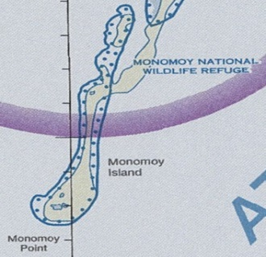
Wildlife Areas
Maintain at least 2000ft agl

4 Types of Hypoxia
- Hypoxic Hypoxia - (most common) with increasing altitude, the partial pressure of oxygen gets lower and the lungs cannot effectively transfer oxygen from the air to the blood
- Hypemic Hypoxia - reduced ability of the blood to carry oxygen to the pilot (caused most commonly by carbon monoxide)
- Stagnant Hypoxia – when the blood flow is compromised for any reason, then sufficient oxygen cannot get to the body tissues (happens in cold temperatures)
- Histoxic Hypoxia - the cell expecting and needing the oxygen is impaired and cannot use the oxygen (alcohol can cause this)

Scuba Diving
12 hours - after diving that does not require controlled ascent (non decompression stop diving), 24 hours - after diving that does require controlled ascent (decompression stop diving)

Spin Recovery
- Throttle – Idle
- Rudder – Full opposite direction of rotation
- Elevator – Full forward
- Rudder – Neutral (after rotation stops)
- Controls – As required to regain level flight
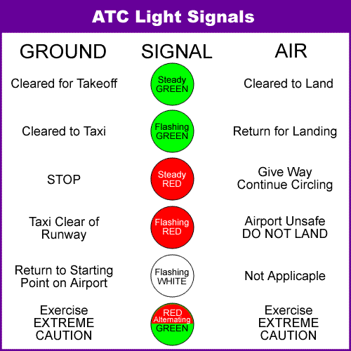
Control Axis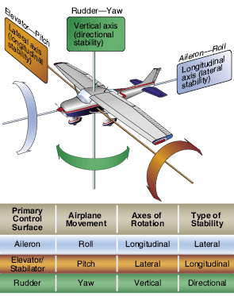
Airspace Equipment & Entry Requirements
Class A - Instrument flight plan, Two way radio communication, Mode C transponder
Class B - Two way radio communication, Mode C transponder, Clearance into class B
Class C - Two way radio communication, Mode C Transponder
Class D - Two way radio communication
Controlled Airspace Dimensions
Class A - Above 18,000 MSL
Class B - Individually tailored, surface to 10,000 MSL, 30 NM mode C veil
Class C - Individually tailored, usually two rings with a radius of 5NM and 10NM respectively, airspace extends to 4,000 AGL but charted in MSL
Class D - Airspace extends to 2,500 AGL but charted in MSL, 5NM diameter, may include extensions to accommodate instrument approaches
Class E - Airspace begins at the surface, 700, 1,200, or 1,500 AGL or 14,500 MSL depending on location, extending up to 17,999 MSL. Also extends above FL600. Below 10,000 MSL 250kts speed limit no speed limit above 10,000 MSL

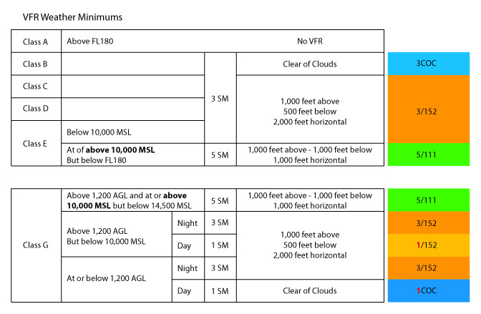

Weather Reports
Airmet (WA) – Hazardous to GA
- 6hrs or as needed
- Sierra – Mtn obstructions/IFR cond
- Tango – Mod turbulence, LLWS <2000AGL, sfc winds >30kts
- Zulu – Mod icing not associated with thunderstorms, freezing levels
Sigmet (WS) – Hazardous to all
- As needed, valid for 2 hrs
- Sand /dust storm, volcanic ash, severe icing, severe or extensive turbulence, visibility < 3SM for 3000 sq. mi.
Convective Sigmet (WST) - Worst
- As needed, valid 2 hrs
- Tornados, embedded thunderstorms, wind shear/gusts hail >3/4 in, sfc winds >50kts, lines 60NM in length affecting 40% of length or Thunderstorms covering 3000 sq. mi.
TAF (5sm radius)
- 00Z, 06Z, 12Z, 18Z
- Valid 24-30hrs
IM SAFE – fitness to fly
- Illness - Is the pilot suffering from any illness or symptom of an illness which might affect them in flight,
- Medication - Is the pilot currently taking any drugs (prescription or over-the-counter),
- Stress - Psychological or emotional factors which might affect the pilot's performance,
- Alcohol – Less than .04 BAC, more than 8 hrs since last drink
- Fatigue - Has the pilot had sufficient sleep and rest in the recent past
- Eating - Is the pilot sufficiently nourished?
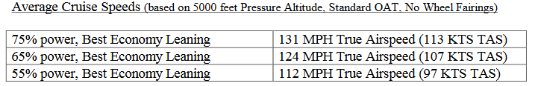

DECIDE model
Detect - the fact that a change has occurred.
Estimate - the need to counter or react to the change.
Choose - a desirable outcome for the success of the flight.
Identify - actions which could successfully control the change.
Do - the necessary action to adapt to the change.
Evaluate - the effect of the action.
PAVE
Pilot
Aircraft
enVironment
External pressures
Squawk Codes
- 1200 Visual Flight Rules (VFR)
- 7500 Hijack
- 7600 Communications failure
- 7700 emergency
- 7777 military intercept code
Engine
- Lycoming O-320 150HP
- Air cooled
- Carbureted
- Horizontally opposed
- Four cylinder direct drive
- Oil cap 8qts (6-8 qts recommended)
- 14V electrical system
- 60Amp alternator

Fuel System
- 42gal/ 38 usable (19 per side)
- Range 615 mi/ 4.7hrs (no reserve)

